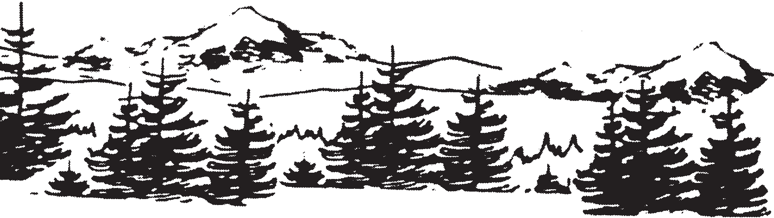

_____________Gateway to the Cascades_______________

BUSINESS LICENSE APPLICATION

FEE: $50.00

Applicant’s Information

Full Name ___________________________________ Phone _______________________

Home Address _______________________________ E-Mail _______________________

Mailing Address (if different than above) ___________________________________________

Business Information

Name of Business _______________________________ Phone _____________________

Street Address ________________________________ E-Mail _____________________

Mailing Address ___________________________________________________________

Property Owner’s Name ___________________________ Phone _____________________

Mailing Address ___________________________________________________________

Type of Business _____________________________ Date to Begin __________________
Is this a home based business? Yes___ No___ Zoning for Property ____________________

Please provide copies of all other business licenses, certificates and registrations required by other Local, State, or Federal jurisdictions.

Official Use Only
Approved ________ Date __________ Received By ______________Fee Paid ___________

Denied __________ Reason for Denial ___________________________________________

